Complete List of NFL Teams
  - Teams by Conference and Division
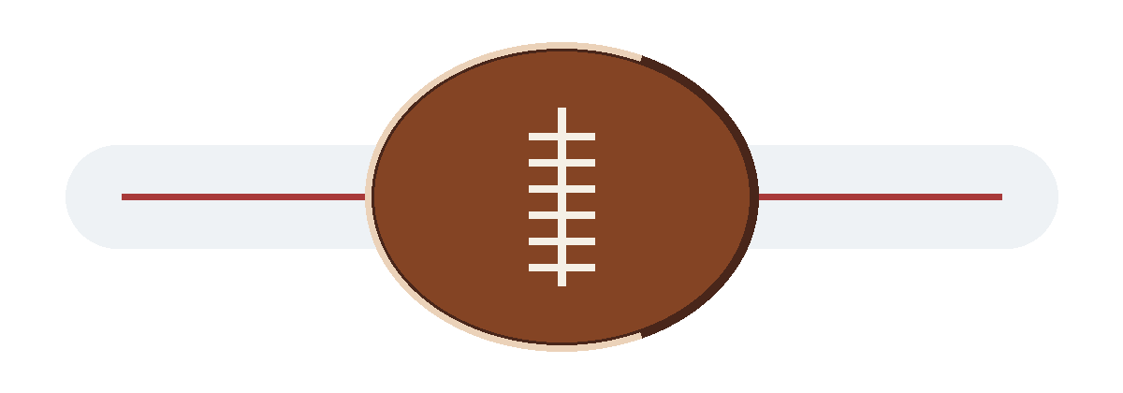
Editable Microsoft Word Edition
Updated for 2026
allfreeprintable.org

Teams by Division
Team | Abbreviation | Conference | Division
Buffalo Bills | BUF | AFC | East
Miami Dolphins | MIA | AFC | East
New England Patriots | NE | AFC | East
New York Jets | NYJ | AFC | East
Baltimore Ravens | BAL | AFC | North
Cincinnati Bengals | CIN | AFC | North
Cleveland Browns | CLE | AFC | North
Pittsburgh Steelers | PIT | AFC | North
Houston Texans | HOU | AFC | South
Indianapolis Colts | IND | AFC | South
Jacksonville Jaguars | JAX | AFC | South
Tennessee Titans | TEN | AFC | South
Denver Broncos | DEN | AFC | West
Kansas City Chiefs | KC | AFC | West
Las Vegas Raiders | LV | AFC | West
Los Angeles Chargers | LAC | AFC | West
Dallas Cowboys | DAL | NFC | East
New York Giants | NYG | NFC | East
Philadelphia Eagles | PHI | NFC | East
Washington Commanders | WAS | NFC | East
Chicago Bears | CHI | NFC | North
Detroit Lions | DET | NFC | North
Green Bay Packers | GB | NFC | North
Minnesota Vikings | MIN | NFC | North
Atlanta Falcons | ATL | NFC | South
Carolina Panthers | CAR | NFC | South
New Orleans Saints | NO | NFC | South
Tampa Bay Buccaneers | TB | NFC | South
Arizona Cardinals | ARI | NFC | West
Los Angeles Rams | LAR | NFC | West
San Francisco 49ers | SF | NFC | West
Seattle Seahawks | SEA | NFC | West

Alphabetical Directory
No. | Team | Abbr. | Conf. | Division | Notes
1 | Arizona Cardinals | ARI | NFC | West
2 | Atlanta Falcons | ATL | NFC | South
3 | Baltimore Ravens | BAL | AFC | North
4 | Buffalo Bills | BUF | AFC | East
5 | Carolina Panthers | CAR | NFC | South
6 | Chicago Bears | CHI | NFC | North
7 | Cincinnati Bengals | CIN | AFC | North
8 | Cleveland Browns | CLE | AFC | North
9 | Dallas Cowboys | DAL | NFC | East
10 | Denver Broncos | DEN | AFC | West
11 | Detroit Lions | DET | NFC | North
12 | Green Bay Packers | GB | NFC | North
13 | Houston Texans | HOU | AFC | South
14 | Indianapolis Colts | IND | AFC | South
15 | Jacksonville Jaguars | JAX | AFC | South
16 | Kansas City Chiefs | KC | AFC | West
17 | Las Vegas Raiders | LV | AFC | West
18 | Los Angeles Chargers | LAC | AFC | West
19 | Los Angeles Rams | LAR | NFC | West
20 | Miami Dolphins | MIA | AFC | East
21 | Minnesota Vikings | MIN | NFC | North
22 | New England Patriots | NE | AFC | East
23 | New Orleans Saints | NO | NFC | South
24 | New York Giants | NYG | NFC | East
25 | New York Jets | NYJ | AFC | East
26 | Philadelphia Eagles | PHI | NFC | East
27 | Pittsburgh Steelers | PIT | AFC | North
28 | San Francisco 49ers | SF | NFC | West
29 | Seattle Seahawks | SEA | NFC | West
30 | Tampa Bay Buccaneers | TB | NFC | South
31 | Tennessee Titans | TEN | AFC | South
32 | Washington Commanders | WAS | NFC | East

Editable Checklist
Check | Team | Watched | Favorite | Attended | Rank | Notes
☐ | Arizona Cardinals | ☐ | ☐ | ☐
☐ | Atlanta Falcons | ☐ | ☐ | ☐
☐ | Baltimore Ravens | ☐ | ☐ | ☐
☐ | Buffalo Bills | ☐ | ☐ | ☐
☐ | Carolina Panthers | ☐ | ☐ | ☐
☐ | Chicago Bears | ☐ | ☐ | ☐
☐ | Cincinnati Bengals | ☐ | ☐ | ☐
☐ | Cleveland Browns | ☐ | ☐ | ☐
☐ | Dallas Cowboys | ☐ | ☐ | ☐
☐ | Denver Broncos | ☐ | ☐ | ☐
☐ | Detroit Lions | ☐ | ☐ | ☐
☐ | Green Bay Packers | ☐ | ☐ | ☐
☐ | Houston Texans | ☐ | ☐ | ☐
☐ | Indianapolis Colts | ☐ | ☐ | ☐
☐ | Jacksonville Jaguars | ☐ | ☐ | ☐
☐ | Kansas City Chiefs | ☐ | ☐ | ☐
☐ | Las Vegas Raiders | ☐ | ☐ | ☐
☐ | Los Angeles Chargers | ☐ | ☐ | ☐
☐ | Los Angeles Rams | ☐ | ☐ | ☐
☐ | Miami Dolphins | ☐ | ☐ | ☐
☐ | Minnesota Vikings | ☐ | ☐ | ☐
☐ | New England Patriots | ☐ | ☐ | ☐
☐ | New Orleans Saints | ☐ | ☐ | ☐
☐ | New York Giants | ☐ | ☐ | ☐
☐ | New York Jets | ☐ | ☐ | ☐
☐ | Philadelphia Eagles | ☐ | ☐ | ☐
☐ | Pittsburgh Steelers | ☐ | ☐ | ☐
☐ | San Francisco 49ers | ☐ | ☐ | ☐
☐ | Seattle Seahawks | ☐ | ☐ | ☐
☐ | Tampa Bay Buccaneers | ☐ | ☐ | ☐
☐ | Tennessee Titans | ☐ | ☐ | ☐
☐ | Washington Commanders | ☐ | ☐ | ☐

Blank Divisions Worksheet

AFC East
1. ______________________________ 2. ______________________________
3. ______________________________ 4. ______________________________

AFC North
1. ______________________________ 2. ______________________________
3. ______________________________ 4. ______________________________

AFC South
1. ______________________________ 2. ______________________________
3. ______________________________ 4. ______________________________

AFC West
1. ______________________________ 2. ______________________________
3. ______________________________ 4. ______________________________

NFC East
1. ______________________________ 2. ______________________________
3. ______________________________ 4. ______________________________

NFC North
1. ______________________________ 2. ______________________________
3. ______________________________ 4. ______________________________

NFC South
1. ______________________________ 2. ______________________________
3. ______________________________ 4. ______________________________

NFC West
1. ______________________________ 2. ______________________________
3. ______________________________ 4. ______________________________

ANSWER KEY

AFC East
Buffalo Bills, Miami Dolphins, New England Patriots, New York Jets

AFC North
Baltimore Ravens, Cincinnati Bengals, Cleveland Browns, Pittsburgh Steelers

AFC South
Houston Texans, Indianapolis Colts, Jacksonville Jaguars, Tennessee Titans

AFC West
Denver Broncos, Kansas City Chiefs, Las Vegas Raiders, Los Angeles Chargers

NFC East
Dallas Cowboys, New York Giants, Philadelphia Eagles, Washington Commanders

NFC North
Chicago Bears, Detroit Lions, Green Bay Packers, Minnesota Vikings

NFC South
Atlanta Falcons, Carolina Panthers, New Orleans Saints, Tampa Bay Buccaneers

NFC West
Arizona Cardinals, Los Angeles Rams, San Francisco 49ers, Seattle Seahawks

Personal Team Rankings
Rank | Team | Reason / Notes
1
2
3
4
5
6
7
8
9
10
11
12
13
14
15
16
17
18
19
20
21
22
23
24
25
26
27
28
29
30
31
32

Instructions and Disclaimer

Editing tables
Click any cell and replace or add text. Add rows through Table Layout if needed.

Using checkboxes
Replace an empty checkbox with a check mark or X, or print and mark by hand.

Printing
Choose US Letter. Use portrait for directory pages and Fit to Printable Area if your printer requests scaling.

Verification
Team names and division assignments were verified August 3, 2026 against NFL.com Teams, NFL.com Standings, and NFL Football Operations.

Disclaimer
Unofficial fan-created reference for personal and educational use. Not affiliated with or endorsed by the National Football League or any NFL team. Team names are used for identification purposes only.

